E3value model:
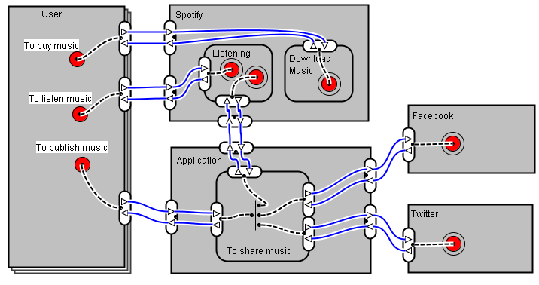

Business Service Model:
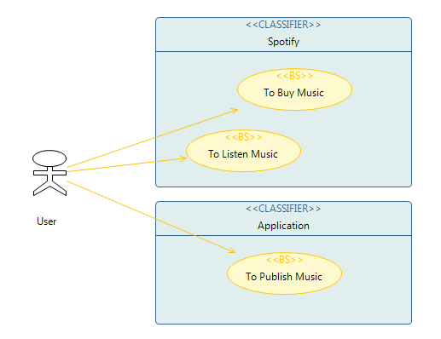

Service Composition Model:
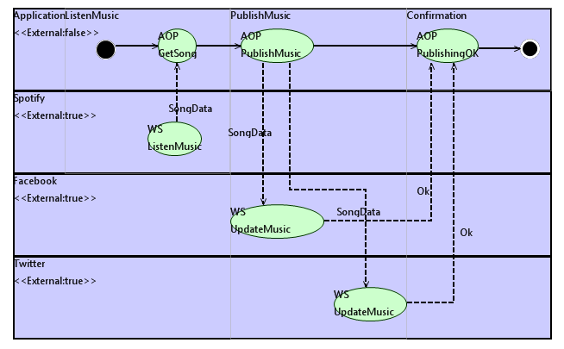

Extended Service Composition Metamodel:

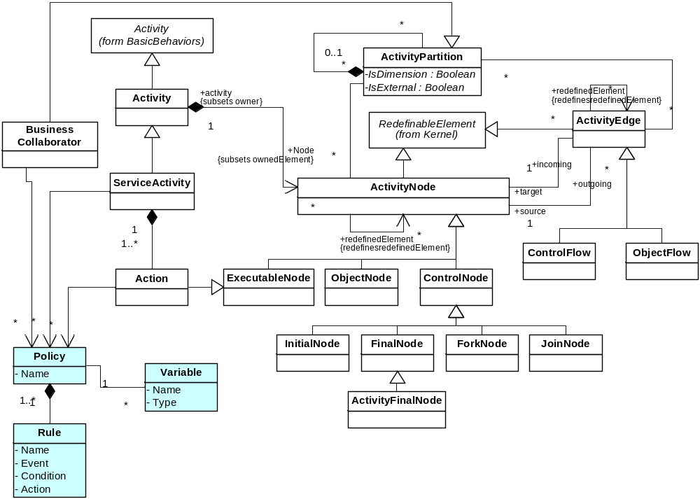

Extended Service Composition Model:
<<Policy>>
OAuthPolicy
Token: token
<<Rule>>
R1
Event: PRE
Condition: event.activityName == scope.name AND token ==null
Action: token=getToken()
<<Rule>>
R2
Event: PRE
Condition: vent.activityName== scope.name AND token!=null AND token.isExpired() == trae
Action: token=renewToken()
<<Rule>>
R1
Event: PRE
Condition: event.activityName
==scope.name
Action: Scope.httpRequest. Credencials = newNetwork Credencial(username,
password);
<<Policy>>
HTTPAuthPolicy
Username: String
Password: String

